Practical - 9
Practical Title: Secure User Registration with Database Insert, Duplicate Email Check, and Password Hashing
Problem Definition: Implement secure user registration by inserting user details into MySQL using MYSQLi. Validate input on frontend and backend, check duplicate email/username, hash passwords using password_hash(), and display appropriate messages.

Theory :
1. Is password_hash() used before storing passwords?

Yes, your register.php uses password_hash($password, PASSWORD_DEFAULT) to hash passwords before storing them in MySQL. During login, password_verify() checks the password.

2. Is duplicate email/username checked?

Yes, your StudentHub project checks for duplicate emails using a UNIQUE constraint in MySQL and handles duplicate-entry errors in register.php by displaying an alert.

3. Are frontend and backend validations consistent?

Partially. Your register.php validates name, email, mobile number, password strength, and password confirmation on the backend. Frontend validation must use the same rules in script.js to be fully consistent.

Implementation/ Output/Result

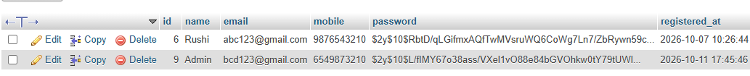

GitHub Repository Link:

https://github.com/rushiaghara25/StudentHub-Portal-2.git

Learning Outcomes:

Implemented secure user registration using PHP and MySQLi.

Applied frontend and backend input validation.

Checked duplicate email addresses.

Used password_hash() to store passwords securely.

Inserted user data into MySQL using prepared statements.

Displayed appropriate success and error messages.

Faculty Remarks: (Keep this blank for faculty)

